PROJECT REPORT: Object-Oriented Library Management System
1. Executive Summary
The Library Management System is a console-based Java application designed to automate core library operations. It models physical library catalog assets—specifically Books, Magazines, and Journals—using structured Object-Oriented Programming (OOP) design patterns. The application facilitates inventory management, tracking asset allocations to users, dynamic loan durations, automated fine calculations for delayed returns, and user-friendly console interaction.
2. System Architecture & Design Principles
The project architecture leverages a modular blueprint focusing on code reusability, single responsibility, and interface segregation.
Key OOP Principles Applied:
- Abstraction: Leveraged via interfaces (BookOperations, etc.) and the abstract class LibraryItem to separate business logic definitions from concrete executions.
- Inheritance: Book, Magazine, and Journal extend the base properties and status-tracking logic of LibraryItem.
- Polymorphism: Method overriding is used effectively across classes (e.g., displayDetails()), enabling heterogeneous collections to print custom schemas dynamically.
- Encapsulation: Class variables use strict private visibility rules, exposing controlled state modifications through explicit getter and setter APIs.
3. Detailed Component Description
3.1 Interfaces (Core Specifications)
The application decouples item actions into specialized contracts to prevent interface pollution.
Interface Name | Target Context | Required Operations
BookOperations | Book Assets | addBook, displayAllBooks, searchBook, issueBook, returnBook, renewBook, calculateFine
MagazineOperations | Periodical Assets | addMagazine, displayAllMagazines, issueMagazine, returnMagazine
JournalOperations | Academic Assets | addJournal, displayAllJournals, issueJournal, returnJournal

3.2 The Core Domain Hierarchy
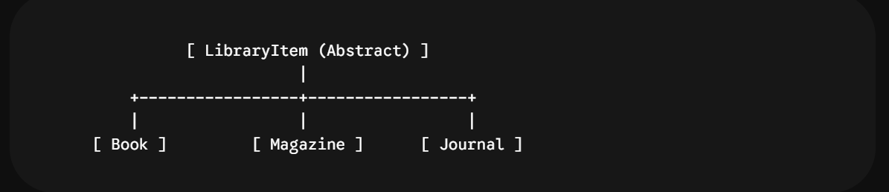A. LibraryItem (Abstract Base Class)
Acts as the central entity representing any physical item present inside the repository.
- State tracked: title (String), isIssued (boolean), issuedTo (String), and dueDate (LocalDate).
- Abstract Hook: Declares public abstract void displayDetails();, forcing child entities to present their data consistently.
B. Book Class
Models a multi-copy standard book asset.
- Extended State: Tracks author, isbn, and an integer counter copiesAvailable.
- Operational Behavior: Allows multiple copies to be held concurrently; track status dynamically reduces or increases count upon allocation.
C. Magazine & Journal Classes
Model short-term periodical assets.
- Extended State: Magazines track issueNumber and publisher. Journals track volume, issue, and publisher.
- Operational Behavior: Operates on single-copy allocations; status switches binaries (Available vs Issued to [User]).
3.3 The Core Controller Engine (Library)
The Library class implements BookOperations, MagazineOperations, and JournalOperations. It functions as the database coordinator and logic broker, housing:
- Collections Storage: Employs explicit List<Book>, List<Magazine>, and List<Journal> data structures.
- System Rules Configurations: Defines invariant rules using constants:
  - BOOK_LENDING_DAYS = 14; (Two weeks loan allowance)
  - PERIODICAL_LENDING_DAYS = 7; (One week allowance)
  - FINE_RATE_PER_DAY = 5.0; (Financial penalty multiplier)
4. Business Logic Flow & Functional Walkthrough
4.1 Check-out (Issuing) Pipeline
When a request to issue an item is initialized:
- Catalog Search: The program scans collection lists using Java Streams API .filter() comparing strings case-insensitively.
- Validation: Checks if the record exists. For books, it verifies copiesAvailable > 0. For periodicals, it validates !isIssued().
- State Mutator: Reduces inventory counter or toggles boolean flags, sets the borrower’s name, and programmatically stamps the future return threshold using LocalDate.now().plusDays(...).
4.2 Return & Overdue Assessment Pipeline
Upon returning an item:
- Calculations: For books, calculateFine() determines chronological delays using ChronoUnit.DAYS.between(dueDate, LocalDate.now()).
- Penalty Enforcement: If the returned day exceeds the due date matrix, a positive integer multiplier scales against FINE_RATE_PER_DAY to produce an overdue balance statement.
- Resetting State: Inventory counters increments, and tracking states are purged to null.
5. User Interface & Input Validation Engine (Main)
The UI is built as an infinite runtime console processing loop managed inside the Main class.
Key UX Highlights:
- Input Sanitization: The utility function readIntegerInput() processes raw input string items through Integer.parseInt(scanner.nextLine().trim()) wrapped tightly inside a nested try-catch block. This prevents crash loops triggered by accidental alphabetical string entry inputs.
- User-Friendly Reporting: Prints tables cleanly with column alignment formatting parameters (e.g., %-25s), ensuring clear readability on modern terminals.
6. Project Metadata Summary
- Language Environment: Java SE 8 or higher (Utilizes Streams API, Lambdas, and java.time engine).
- Storage Framework: Memory-resident Collections (ArrayList).
- Target Deployment: Educational Training Labs, Command-Line Utilities, Core OOP System Demonstrations.
- Extensibility Index: High. New items (e.g., DVD, Laptop) can easily inherit from LibraryItem without breaking the current Library system.

